4. Git-HOL :
Verify master branch status
git checkout master
git status

Create and switch to GitWork branch
git checkout -b GitWork

Create hello.xml file on GitWork
echo "<note><to>User1</to><from>Branch</from><body>Branch Content</body></note>" > hello.xml

Update hello.xml content and check status
echo "<note><to>User1</to><from>Branch</from><body>Updated Branch Content</body></note>" > hello.xml
git status

Stage and commit changes on GitWork
git add hello.xml
git commit -m "Add and update hello.xml in GitWork branch"

Switch back to master
git checkout master

Create conflicting hello.xml on master
echo "<note><to>User2</to><from>Master</from><body>Master Content</body></note>" > hello.xml

Stage and commit changes on master
git add hello.xml
git commit -m "Add conflicting hello.xml in master branch"

Observe commit log
git log --oneline --graph --decorate –all

View differences between branches
git diff master..GitWork

Launch diff tool (P4Merge)
git difftool master..GitWork

Merge GitWork into master (triggers conflict)
git merge GitWork

Check file contents / Launch merge tool to resolve conflict
cat hello.xml
git mergetool

Stage and commit resolved conflict
git add hello.xml
git commit -m "Resolved merge conflict between master and GitWork"

Check status and update .gitignore with backup files
git status
echo "*.orig" >> .gitignore

Stage and commit .gitignore
git add .gitignore
git commit -m "Add backup files to .gitignore"

List branches and delete merged branch
git branch
git branch -d GitWork
Observe final log history
git log --oneline --graph –decorate

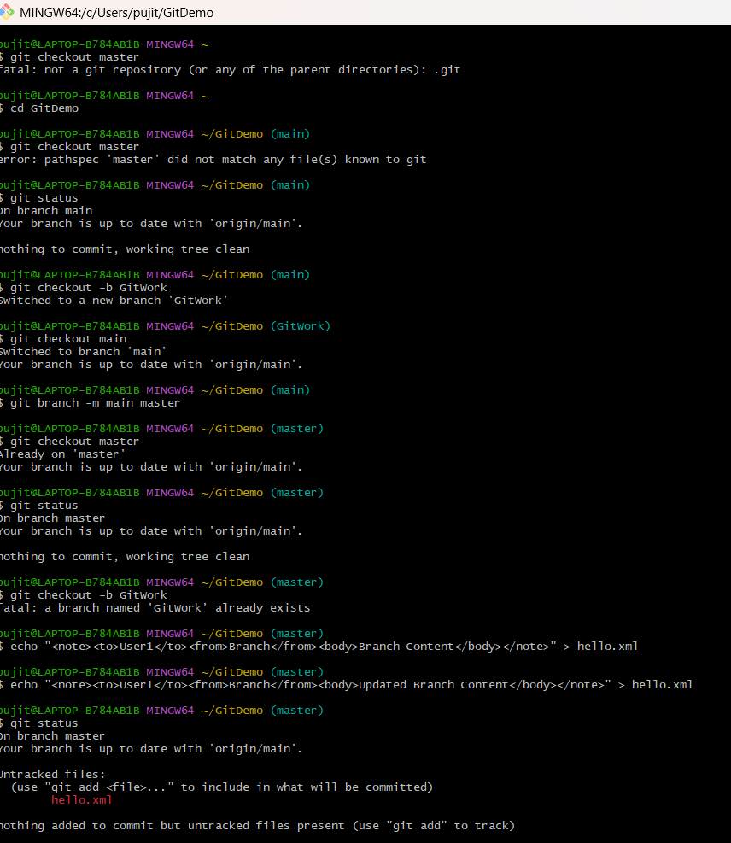
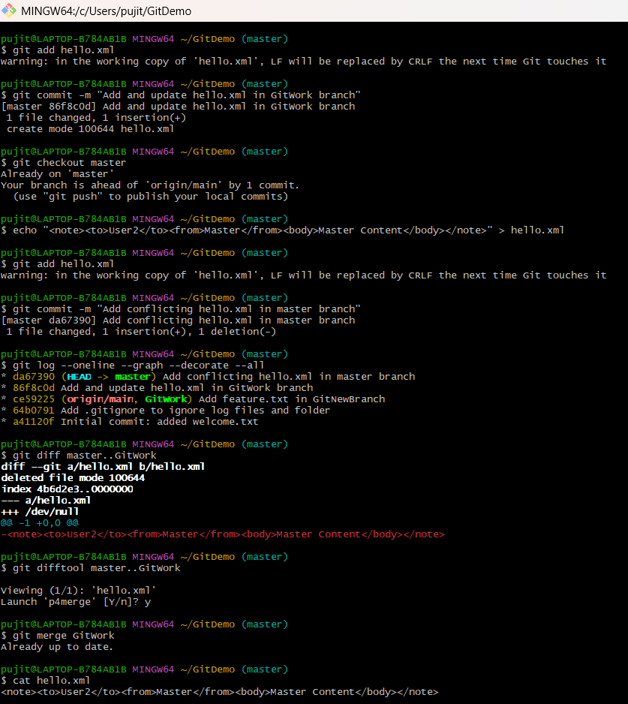
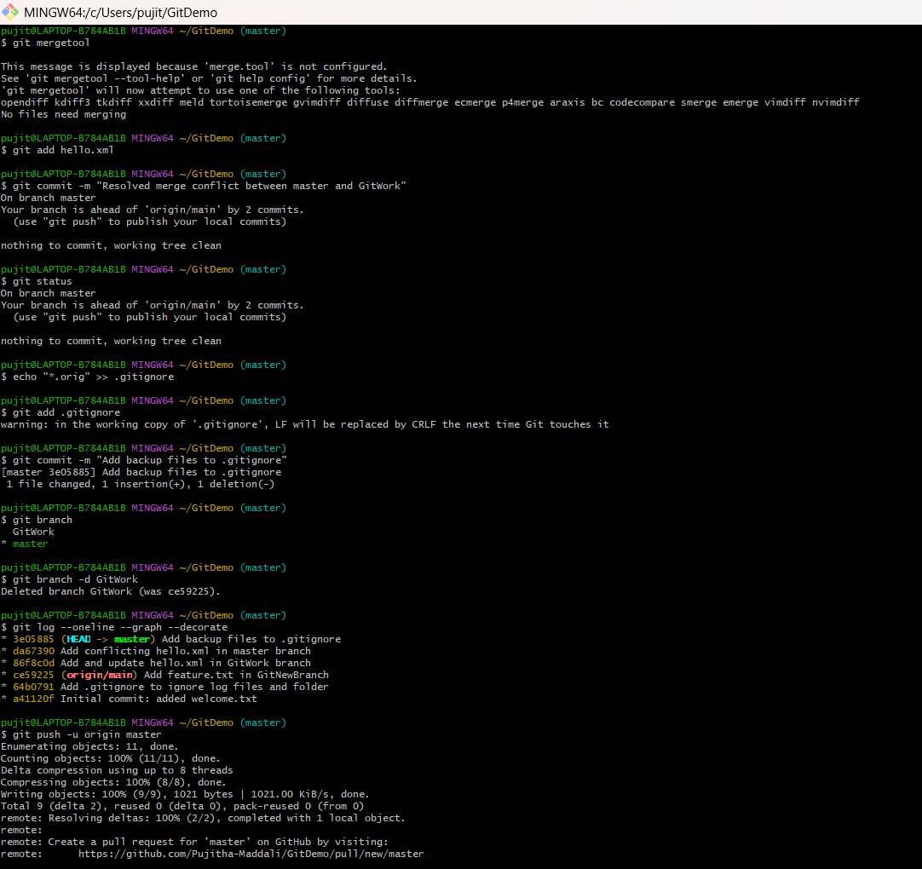

P4Merge:
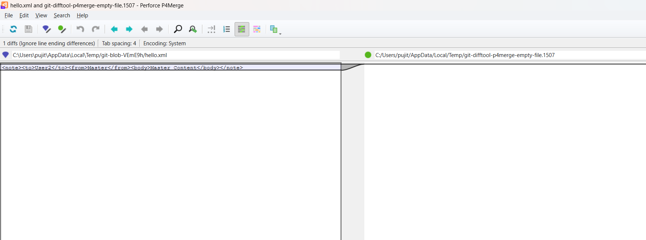

Hello.xml Committed into GitHub :
